*Visualization Engineering, Fall 2018*

**Visualization of Video Game Sales data in Tableau**

Group 16

Nupur Dongare

Sreya Pedamalla

929-435-2083

313-564-9222

[dongare.n@husky.neu.edu](mailto:dongare.n@husky.neu.edu)

pedamalla.s@husky.neu.edu

**Percentage of Effort Contributed by Student 1: 50%**

**Percentage of Effort Contributed by Student 2: 50%**

**Signature of Student 1: Nupur Dongare**

**Signature of Student 2: Sreya Pedamalla**

**Submission Date: 11/12/2018**

**Analysis of User Counts and User Scores**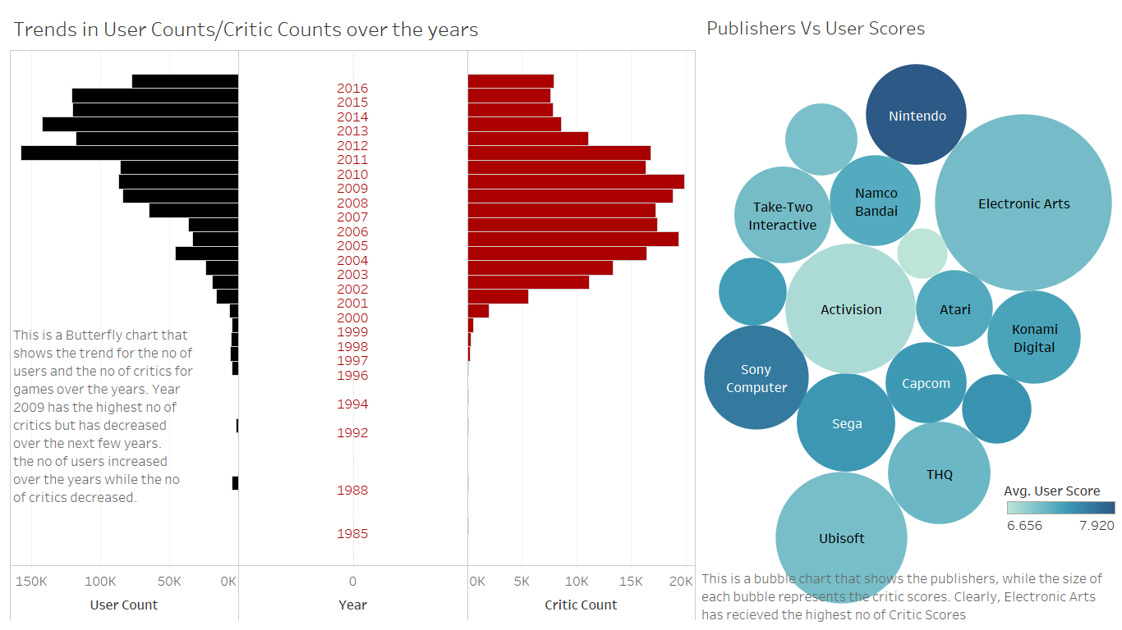

**Market Ownership of Publishers:**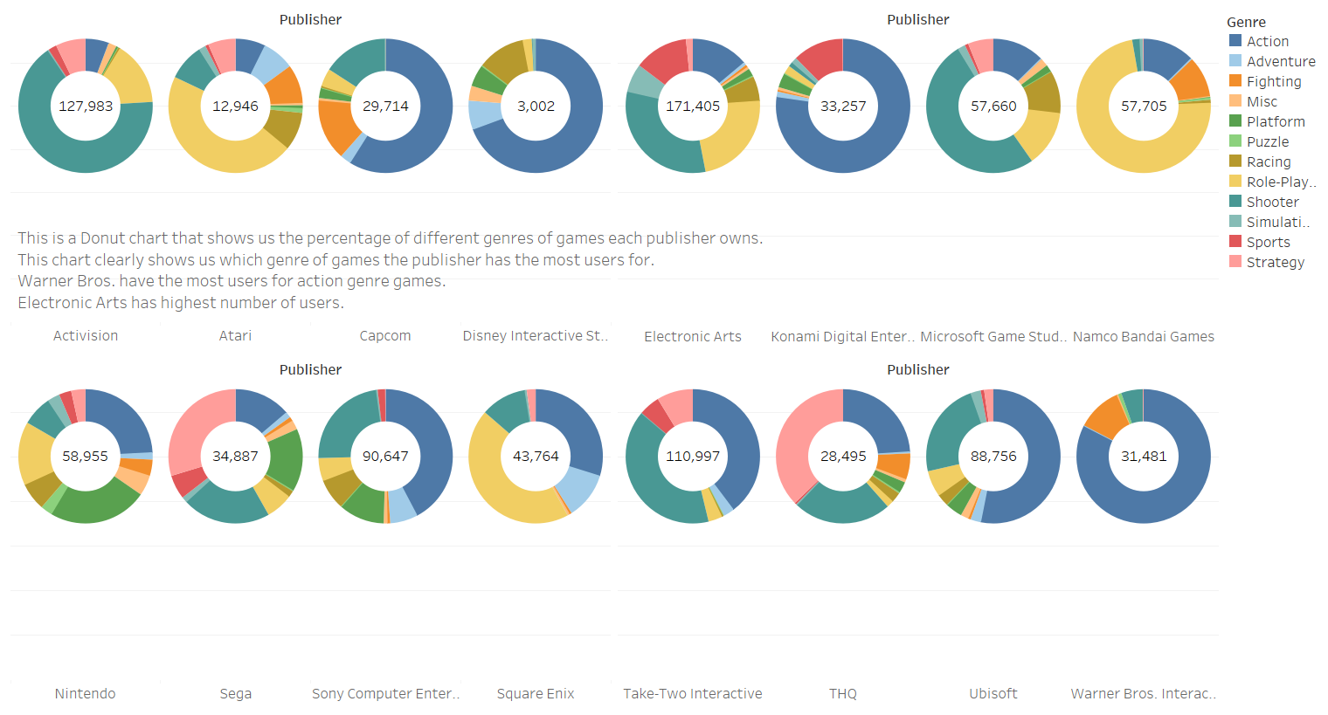

**Yearly trends in User Scores and User Counts**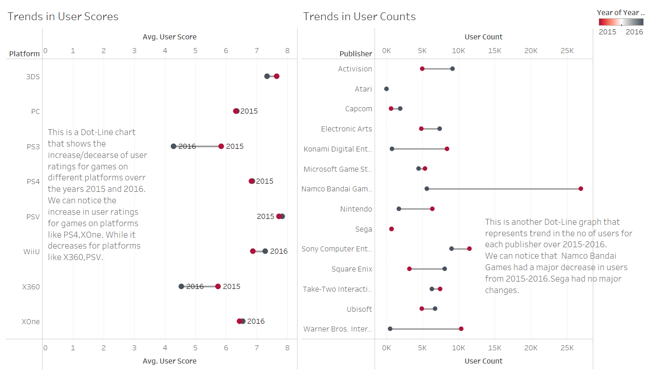

**Regional and Global Sales for popular 16 publishers**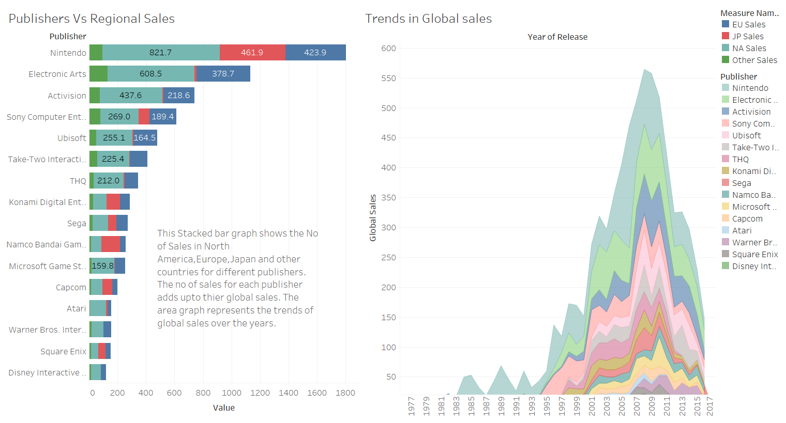

**Genre & Platform Analysis:**

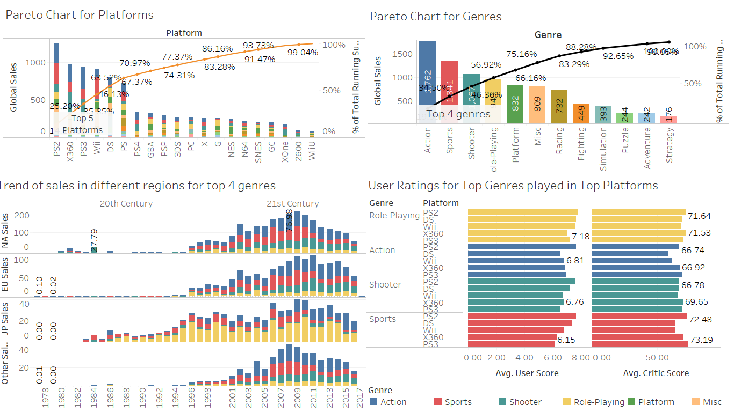

**Global Sales Analysis:**

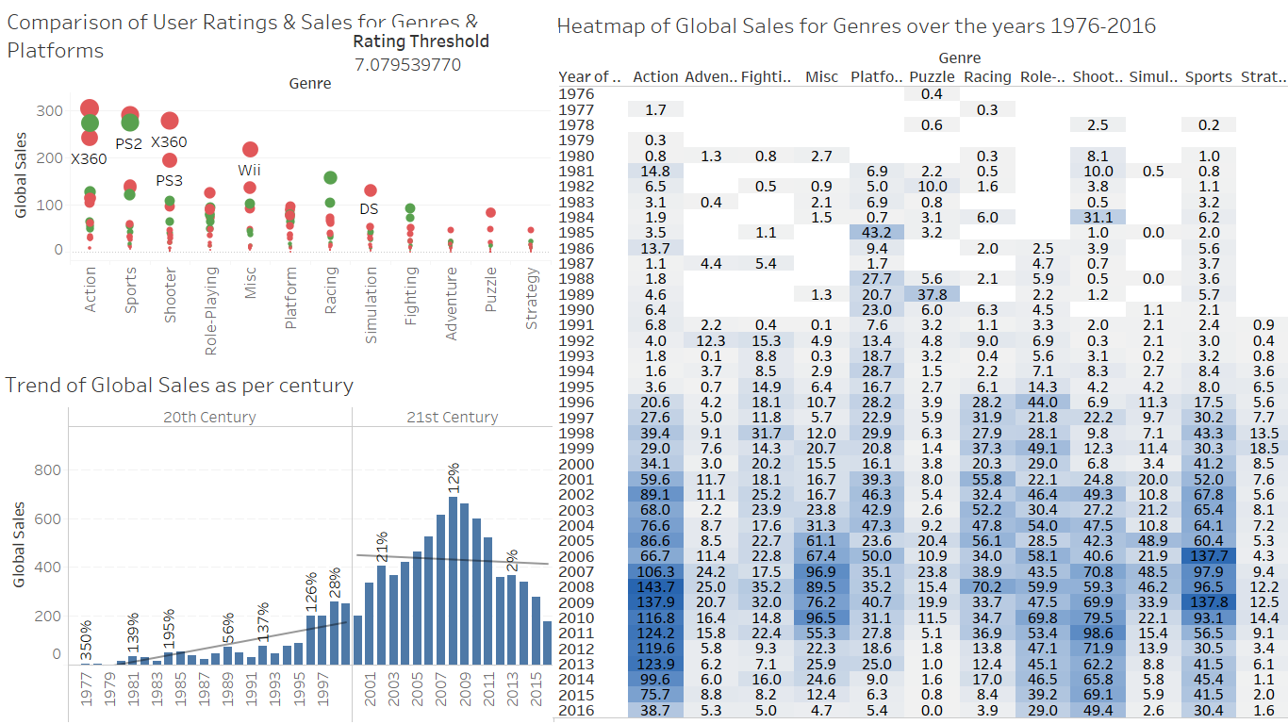

**Conclusion:**

We analyzed global Video Game Sales dataset to create insightful charts and dashboards. Although, there weren’t Critic and Users scores for every game, the dataset was considerably clean and consistent.

Insights drawn:

* Global sales figures although increased in 21st century, the overall growth is declining.
* Good sales figures for a platform does not necessarily mean good user ratings.
* User Ratings were used more after 2009, also more users participated after 2009.
* Top Publisher is Nintendo, Top Genre is Action, Top Platform is PS2, highest rated platform is DS.
* EA has highest number of users and Warner Brothers is biggest owner of Action genre.
* Role-playing genre is most popular in Japan with highest sales there and Namco Bandai Games is best publisher for the genre.